****

Software Development: Data Structures

(H16Y 35)

Outcomes 2 (part 2), 3 and 4

Exercise 4

“Develop and test a small program that uses standard collection classes”

A supervised open-book practical assessment

This final practical exercise allows you to make use of the standard collection class libraries to help you provide the solution to a given problem

A part solution is provided, and you will be required to insert code as indicated to ensure the completed solution is fit for purpose

The program makes use of the Hashtable Collection Class, to allow for the storage and subsequent quick access to information relating to students attending college

The Hashtable will use a student’s last name as the Key and will store the corresponding Student object as a Value

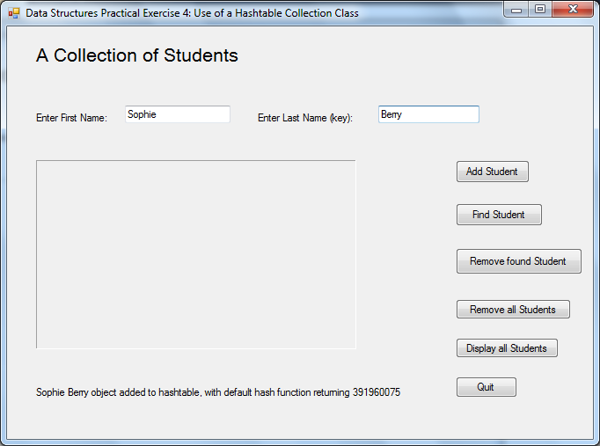

The Hashtable program user interface

You are required to carry out the following:

Launch the part solution in Visual Studio and open Form1.cs

Task 1

Create a Hashtable instance called “StudentNames”

Task 2

Complete the ADD a student entry event handler method

Task 3

Complete the FIND a student entry event handler method

Task 4

Complete the DELETE a student entry event handler method

Task 5

Complete the DELETE ALL student entries event handler method

Task 6

Complete the DISPLAY ALL student entries event handler method

Prior to submission:

* Ensure your completed solution includes your name and date of implementation
* Once you have provided the code insertions, complete the attached acceptance test log to confirm the program behaves as expected

Ensure you document any errors found and how you fixed the errors

* Take a screenshot of the user interface having provided your full name and added these details to the Hashtable

Save this screenshot together with your full solution and your completed test log to your lecturer’s travelling disk